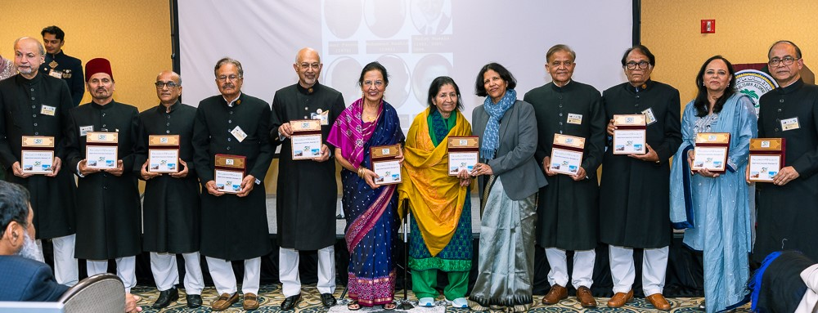
AAA-DC Presidents
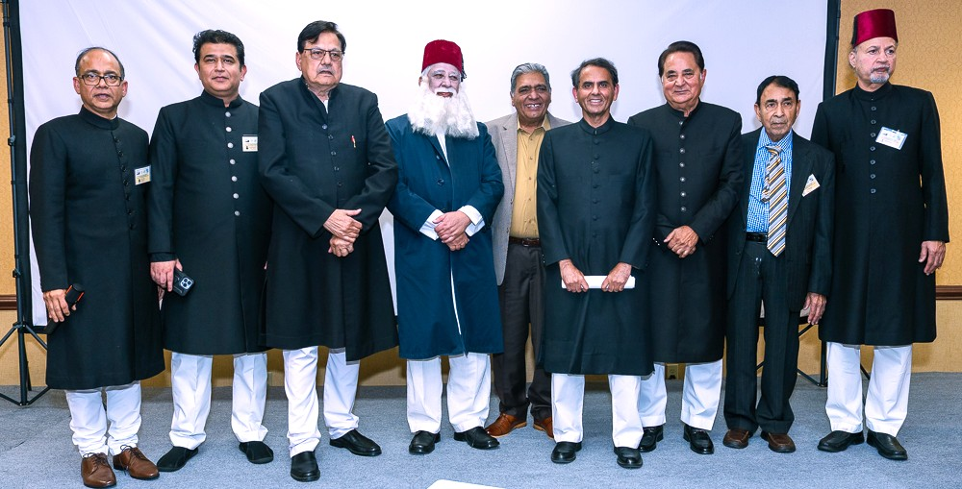
Cast of the play Woh Shahr-e-Tarab Roomano Ka
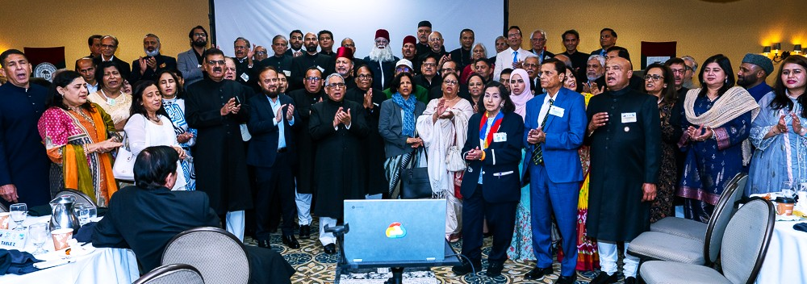
AMU Tarana chorus
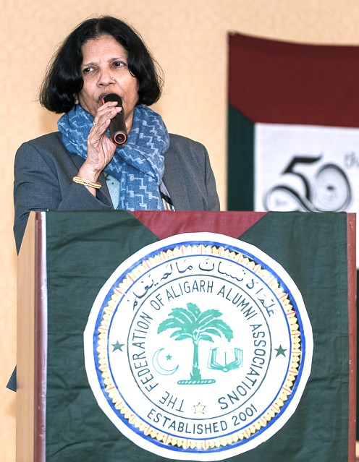
AMU Vice-Chancellor Prof. Naima Khatoon
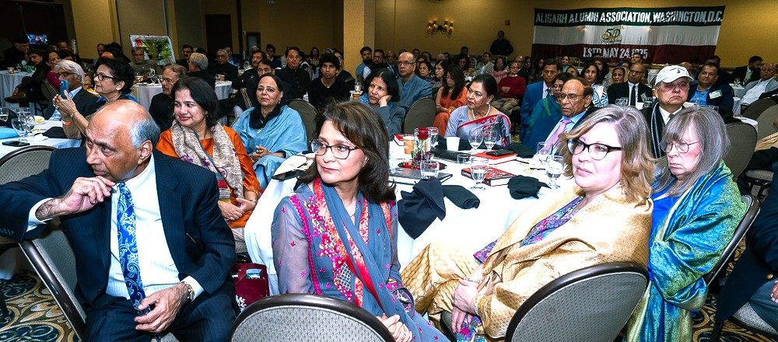
View of the audience
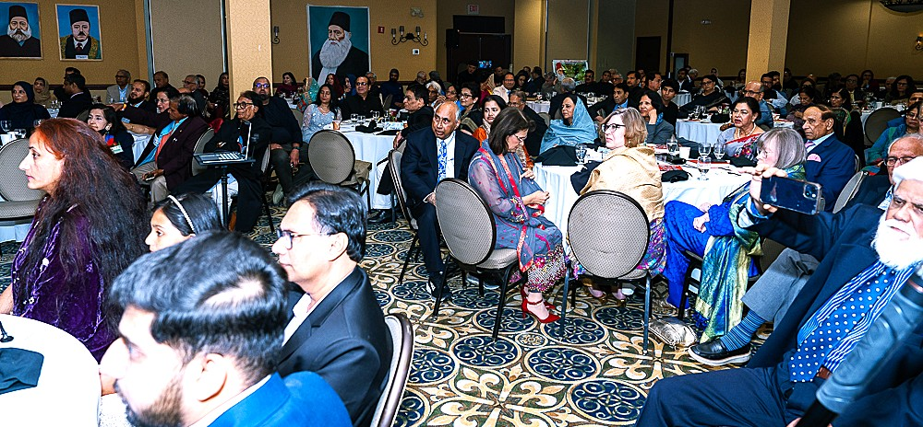
View of the audience
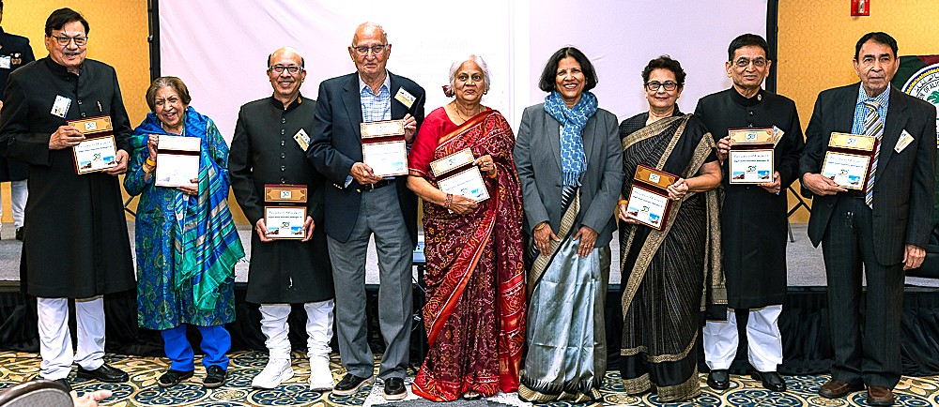
Founders of the Association with AMU VC
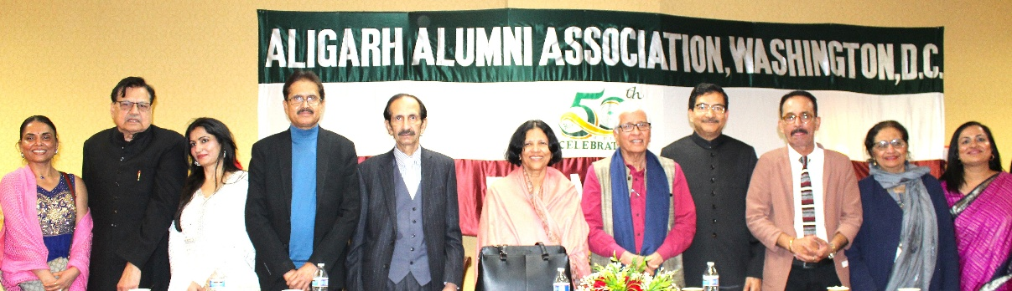
Participating poets in the mushaira

